**DAILY ONLINE ACTIVITIES SUMMARY**

|  |  |  |  |  |  |  |  |  |
| --- | --- | --- | --- | --- | --- | --- | --- | --- |
| **Date:** | **18-05-2020** | | | | | **Name:** | **Kavya R Shetty** | |
| **Sem & Sec** | **VI A** | | | | | **USN:** | **4AL17CS042** | |
| **Online Test Summary** | | | | | | | | |
| **Subject** | | **CNSC IA Test** | | | | | | |
| **Max. Marks** | | **60** | | **Score** | | | **44** | |
| **Certification Course Summary** | | | | | | | | |
| **Course** | **FACE 360 Capsule** | | | | | | | |
| **Certificate Provider** | | | **FACE Prep** | | **Duration** | | | **6th April-21st May 2020** |
| **Coding Challenges** | | | | | | | | |
| **Problem Statement:**  **1.** Using methods charAt() & length() of String class, write a program to print the frequency of each character in a string.  **2.** Write down a java program to print even and odd numbers series respectively from two threads: t1 and t2 synchronizing on a shared object Let t1 print message “ping — >” and t2 print message “,—-pong”.  **3**.Write a C Program to check whether two strings are anagram or not  hv    . | | | | | | | | |
| **Status:Completed** | | | | | | | | |
| **Uploaded the report in Github** | | | | | **Yes** | | | |
| **If yes Repository name** | | | | | [https://github.com/kavyashetty-765/DAILY-STATUS](https://github.com/kavyashetty-765/DAILY-STATUSOnline-Coding) | | | |
| **Uploaded the report in slack** | | | | | **Yes** | | | |

**Online Test Details**

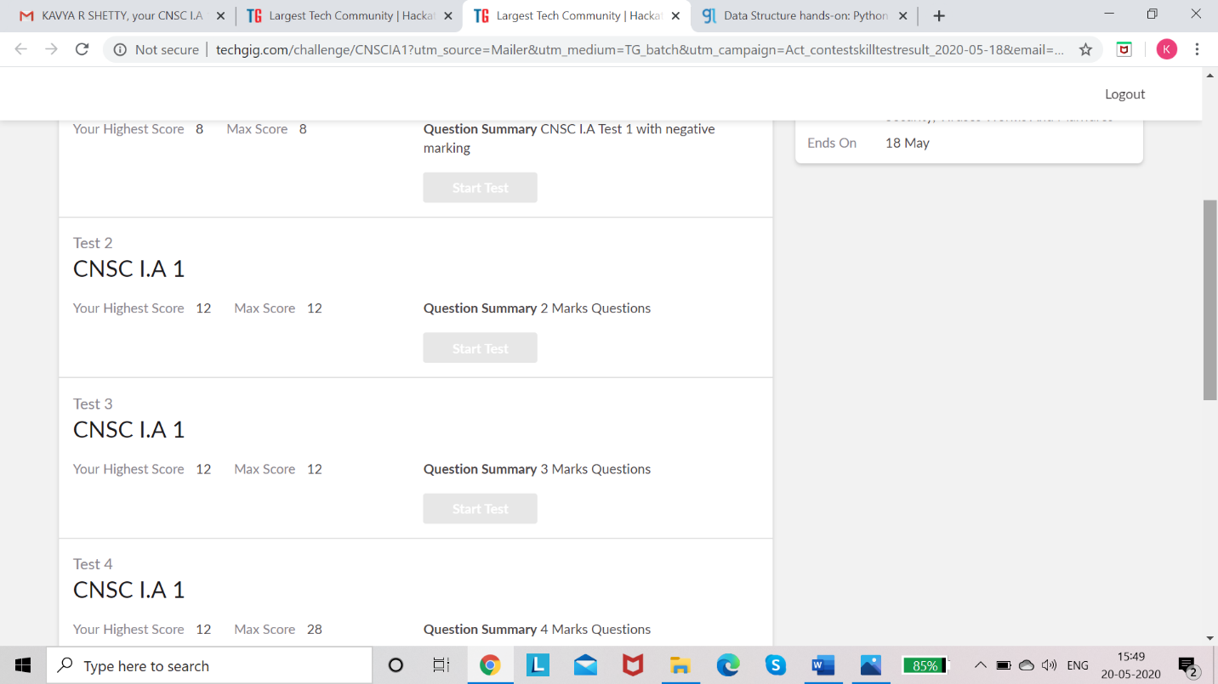**Online Certification Details**

FACE 360 CAPSULE

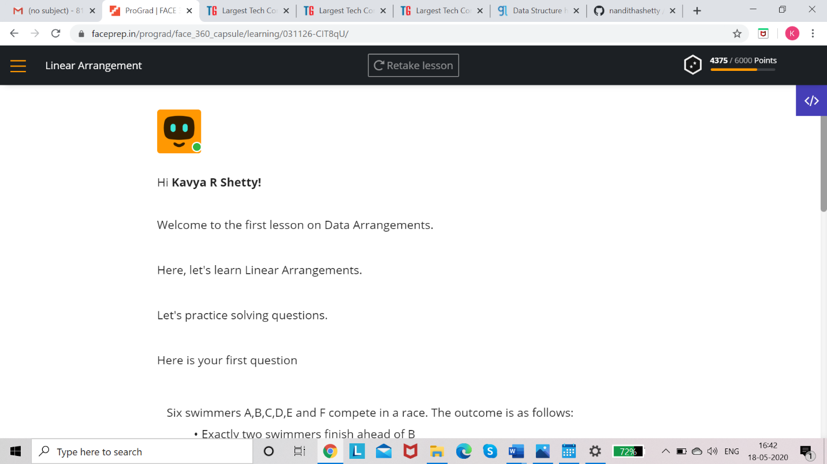

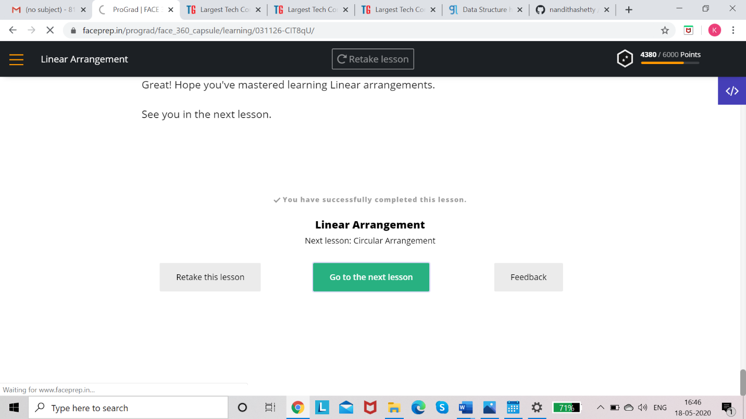

**Coding Challenge Details**

1. Using methods charAt() & length() of String class, write a program to print the frequency of each character in a string.

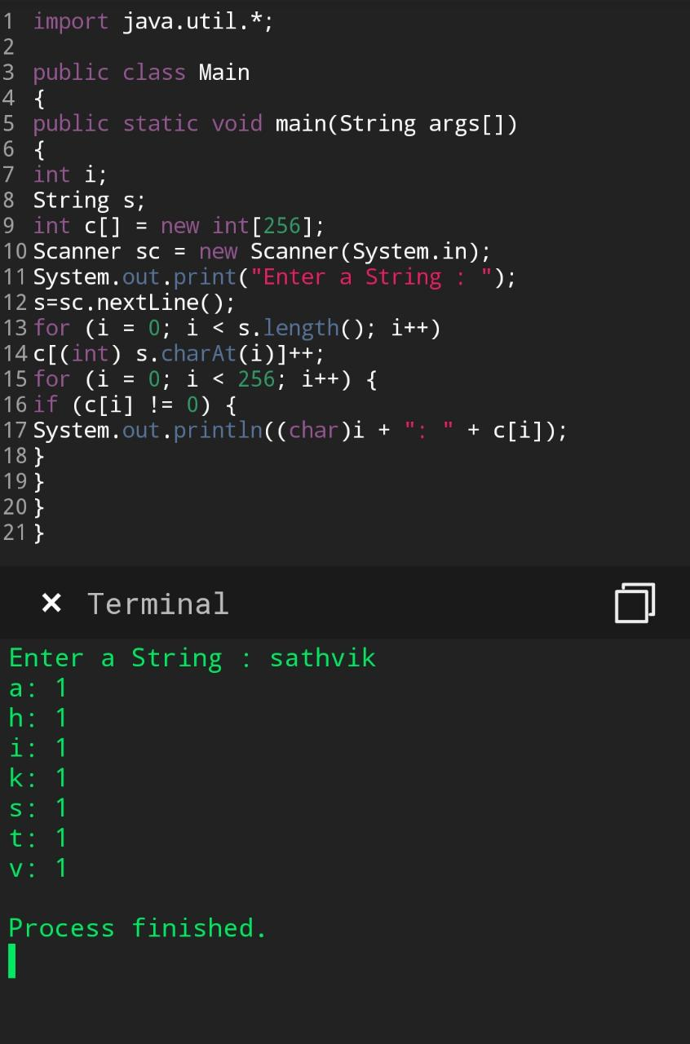

1. Write down a java program to print even and odd numbers series respectively from two threads: t1 and t2 synchronizing on a shared object  
   Let t1 print message “ping — >” and t2 print message “,—-pong”.

